Edit Product (Clothing Selected) – Accessed via Staff View Products

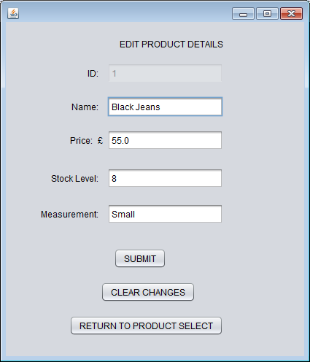

Edit Product (Footwear Selected) – Accessed via Staff View Products

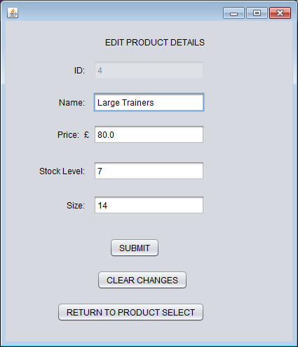

Edit CustomerDetails – Accessed via Customer Home

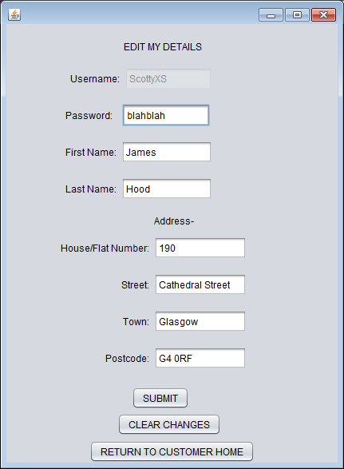

You should also now code:

Delete Product function (accessed via Staff View Products)

Unregister as a Customer (accessed via Customer Home)